**Step 1: Copy Test Data to the SMB Share**

1. Open the **mapped network drive (Z:)** in **File Explorer**.
2. Copy and paste a test file (e.g., testfile.txt) into the shared folder.
3. Wait for the file to appear in the directory.

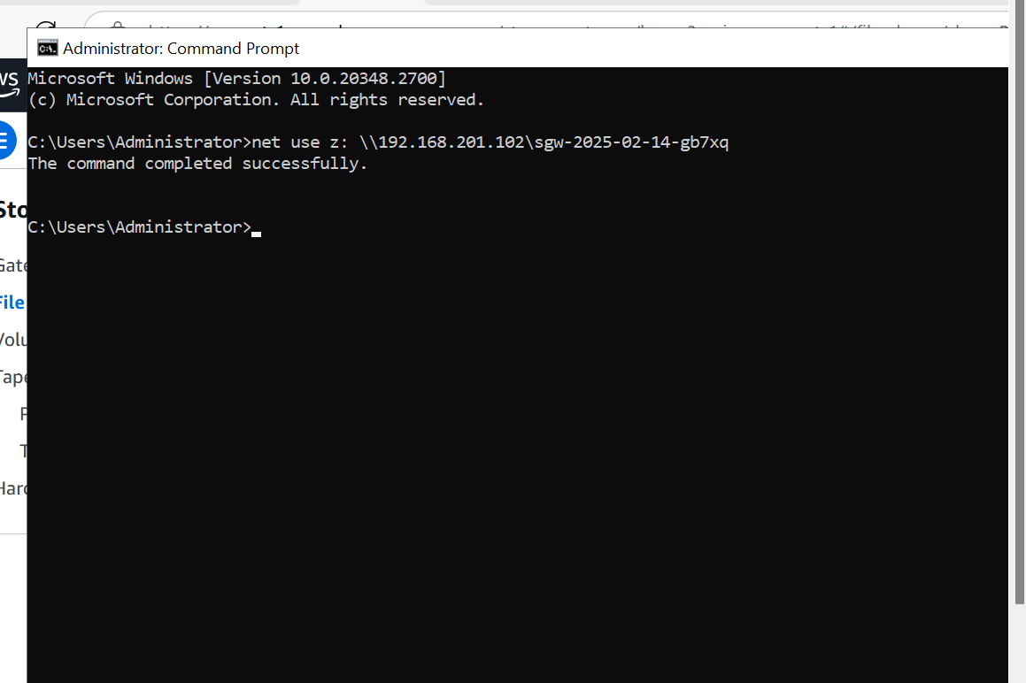

**Step 2: Verify Data Sync to S3 Bucket**

1. Log in to the **AWS Management Console**.
2. Navigate to **S3** and open the bucket linked to the SMB file share.
3. Check if the uploaded file (testfile.txt) appears in the bucket.
4. If the file does not appear immediately, wait a few minutes and refresh the S3 console.

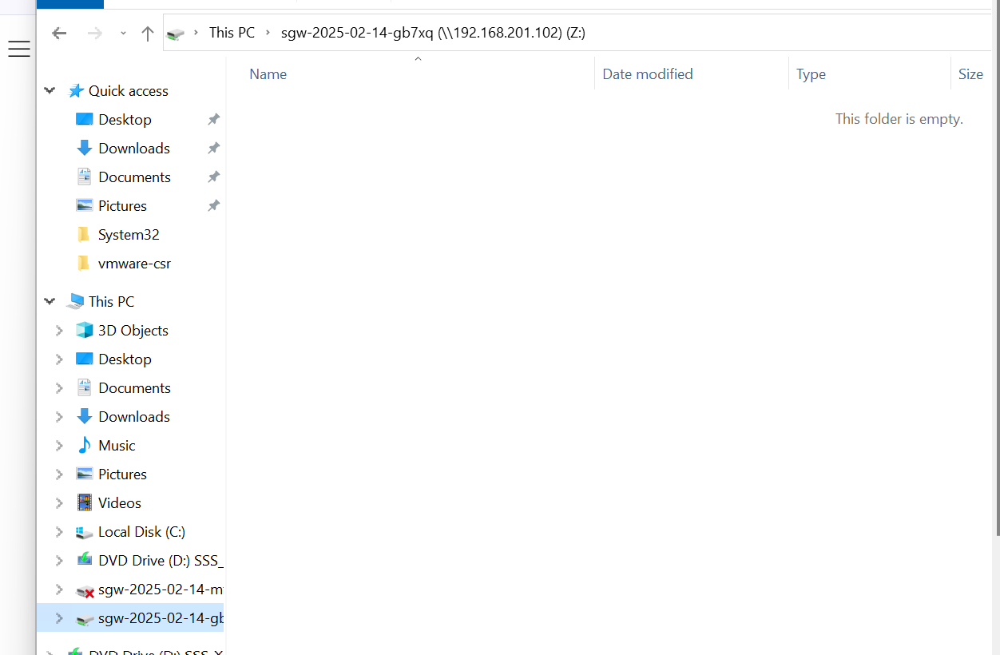

**Step 3: Test File Retrieval from S3 via SMB**

1. Delete the file from the SMB share (Z:\testfile.txt).
2. In the **AWS S3 Console**, manually upload testfile.txt back into the S3 bucket.
3. Return to the **Windows system** and refresh the **SMB share folder (Z:)**.
4. Confirm that testfile.txt is visible and synchronized from S3.